Champions of Inclusion

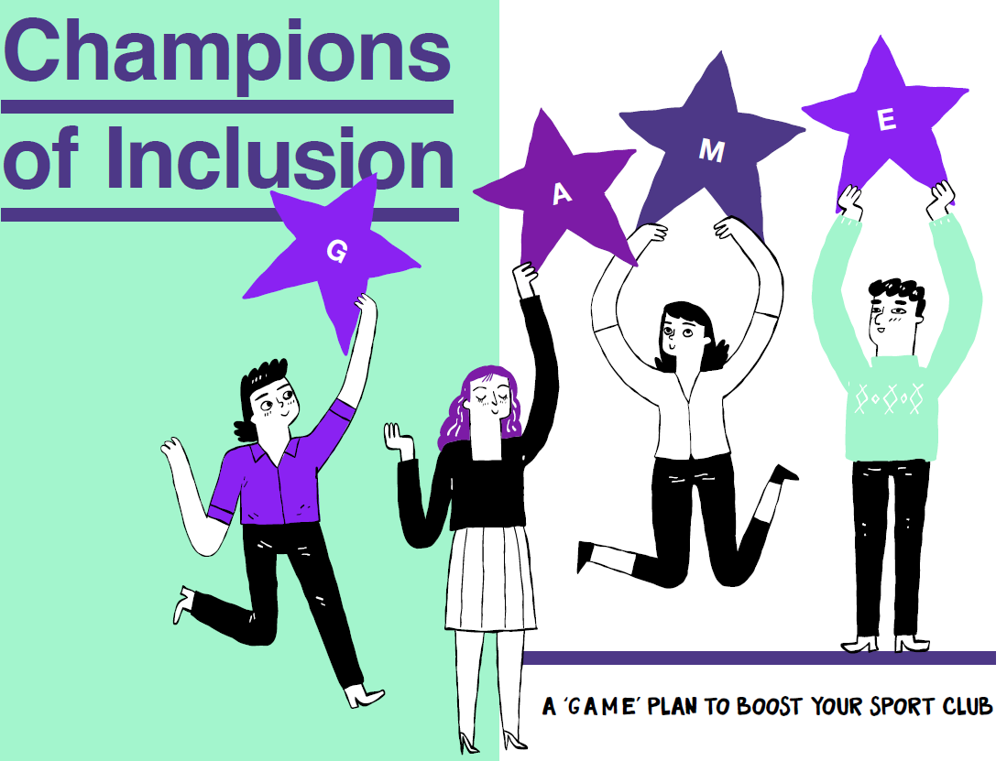

Strategy document

This strategy document is part of the ‘Champions of Inclusion: A GAME plan to boost your sport club’ publication. It is designed to help you outline the strategic process for growth and sustainability of your sport club on the four strategic GAME-areas: governance, advocacy, membership and events.

The document includes a detailed vision for the club, short-term goals, specific actions to be taken, resources, timescales and indicators to monitor progress.

It can be used and adapted as you like as it is unique to your own club.

GOOD LUCK!

Table of contents

ABOUT US 3
MISSION AND VISION 3
STRATEGIC PLAN [INSERT YEAR] 3
Identification of the current challenges 3
Short-term goals 4
ACTION PLAN 5
Detailed overview of actions 5
Indicators to monitor progress 6

This publication is a result from the Erasmus+ project +PLUSS. The acronym stands for ‘LGBTQI+ Policy and Leadership in Sport and Society’. The project
aimed to enhance the inclusion and participation of LGBTQI+ athletes in European grassroots sport through combatting discrimination, addressing intolerance and establishing an inclusive sport culture where all can participate.

Project Partners: EGLSF, Sportieq, Out For The Win, Atlasz Sportegyesület, Team München, Queer Sport Split, Pan Idraet, Out In Slovenija, Deutsche Sporthochschule Köln

For questions or remarks, please contact eglsf@eglsf.info or michele.mommi@eglsf.info

Read more about +PLUSS here.

Funded by the European Union. Views and opinions expressed are however those of the author (s) only and do not necessarily reflect those of the European Union or EACEA. Neither the European Union nor the granting authority can be held responsible for them.



ABOUT US

You can use this space to give a short introduction on your organisation: founding year, main activities, target group, … .

MISSION AND VISION

Before getting started, it can be helpful to clearly formulate your mission and vision once more. Your eventual strategy should contribute to your mission and reflect your vision.
- Your mission explains what your organisation does, who your target group is and mentions core activities.
- Your vision entails a long-term vision, it is what you hope to achieve in the future, outlining your ultimate goal.

For example, the mission and vision of EGLSF:
- Mission: EGLSF wants to be the leading voice for LGBTIQ sport in Europe, promote the interest of LGBTIQ sport organisations and challenge LGBTIQ discrimination in sport in Europe.
- Vision: EGLSF believes in equality, diversity and inclusion in sport.

STRATEGIC PLAN [INSERT YEAR]

The goal of this document is to make a plan on how to improve your club on the four strategic areas of development that were addressed in the Guidelines: governance, advocacy, membership and events.

A helpful first step can be an analysis of current challenges your club faces on either one of these topics. And to complement this analysis with the desired outcomes.

Identification of the current challenges

There are different tools to help you identify current challenges that disrupt realising your vision. Feel free to use whichever tool feels most comfortable.

Some examples:

- SWOT (strengths, weaknesses, opportunities and threats) analysis is helpful evaluating your overall situation. An advantage of the SWOT-analysis is that it immediately helps you identify new possibilities, which can be useful when solving certain challenges.
- 5 Why’s is a method to help you discover the root of the problem by asking “Why?” five times. This can be useful to make sure that you are actually taking on the underlying issues instead of their symptoms.
- Mind mapping can be an effective technique to visualise thoughts and ideas related to a problem and explore different aspects of that problem.

Short-term goals

After identifying current challenges, it is equally important to translate these insights into general goals and concrete short-term objectives. These goals will decide which steps you should take next.

An example for the topic of membership;

- General goal: improve the awareness on safe(r) spaces among members.
- Concrete objective: implement a general code of conduct.

While creating goals and objectives, try to keep it realistic and reachable. If you want to keep focus and clarity, it is recommended to formulate between three and five goals.

Your goals should always contribute to the mission and vision of your organization.

ACTION PLAN

Your action plan is the part where all the work you did before should add up. You use your mission and vision, identified challenges and defined goals to formulate concrete steps.

Detailed overview of actions

This part of your strategy links concrete actions to each objective you formulated earlier. The table below helps you map the necessary conditions in order to successfully complete the action.

Continuing with the example on membership and the goal to improve awareness on safe(r) spaces among members, your table could look like this:

Objective | Action | Timing | Who is involved | Resources
Implement code of conduct | Identify threats for a safe(r) space | Jan - Mar | Club members, coaches, board | Time, meeting room, survey software …
 | Write code of conduct
 | Work out dissemination strategy
 | Create procedures in case of violation
…

You can always adjust this table with extra/other kinds of information, such as general goal, location, specific budget, …

Indicators to monitor progress

Once you have set out your goals and actions, it is helpful to define indicators to monitor your progress. The table below helps you formulate specific and measurable indicators.

You can always adjust this table with extra/other kinds of information.

Action | Indicator type | Unit of measurement | Baseline value | Target value

Apart from indicators, this document can be a good place to clarify how, when and by who this progress will be monitored and evaluated.

